UNIFIBER
Commercial
B2B

Annex 3A
Service Description
21 November 2022

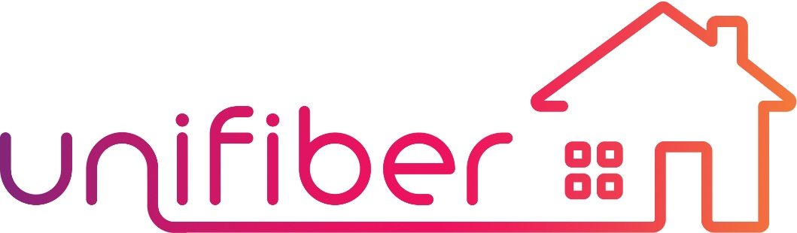

Table of Contents
1. Table of Contents 2
2. General Provisions 3
3. Introduction 3
3.1 Unifiber Mission 3
3.2 Unifiber Network 3
3.3 Unifiber Network Components 4
3.4 Backhauling 5
3.5 Network Design Principles 6
3.6 Network Quality Standards 6
3.7 Demarcation & Operator Authorization 6
Business Access Point 6
POPs 6
3.8 Ownership, Usage and Protection of Network and Equipment 7
4. Unifiber FTTX Network 7
4.1 Homes Passed Deployment 7
4.2 Business Connection 8
5. Service Description 8
5.1 Wholesale Single Fiber (1F) Access 9
5.2 Wholesale Fiber Pair Business Access 9
5.3 Rackspace 10

General Provisions
This Service Description for Wholesale Business Access is designed to create a common understanding about the service & product offering of Unifiber for Wholesale Business Access (SD) and
This SD will be updated or adjusted according to operational needs.

Introduction

Unifiber Mission
Unifiber’s mission is to deploy and exploit an extensive FTTx-network in specific areas of the Walloon region of Belgium, the so called Unifiber Footprint, covering - 600.000 Homes Passed (including most SME, some Corporates, Public Buildings, etc.).
Growing demand for high-speed internet is the primary driver for this new access technology which enables experiencing true Gigabit internet.
We believe dedicated P2P fiber connectivity is the best access method to support this demand. By building a dense P2P FTTx network, we want to provide a future-proof access technology which will allow our Operators to offer a full range of telecommunication- and entertainment services to both residential as well as business Business Customers for the next decades to come.
Unifiber’ objective is to have its FTTx network deployed from 2022 until 2028.

Unifiber Network
Unifiber fully owns and manages its FTTx-network. Our network is passive and P2P and mainly installed underground at a depth of 40 to 60 centimeters, but it also makes use of aerial and façade deployment types. All work on our network is carried out by contractors under direct contract with Unifiber and according to processes which we continuously monitor and evaluate.
The Unifiber network is an open network, offering open and non-discriminatory fiber access to all interested Operators. This approach allows to offer Operators the freedom and flexibility to define and set-up the services and products to their Retail Customers or Service Providers as they like.
Unifiber’s FTTx Network will be accessible to Operators in a large number of POP locations in the Walloon region. Each Area POP covers a Fiberzone. At these POP locations, Unifiber offers rack space and power services to install all necessary equipment to cover one or more Fiberzones.
In each Deployment Area, consisting of several POPs and Fiberzones, Unifiber has identified at least one Central POP, the other POPs are then called Area POPs. All Area POPs are connected by a POP-ring to a Central POP (see Figure 1). An Area POP covers 2.500 to 3.800 Homes Passed, a Central POP connects in principle 10.000 to 20.000 Homes Passed (if possible).
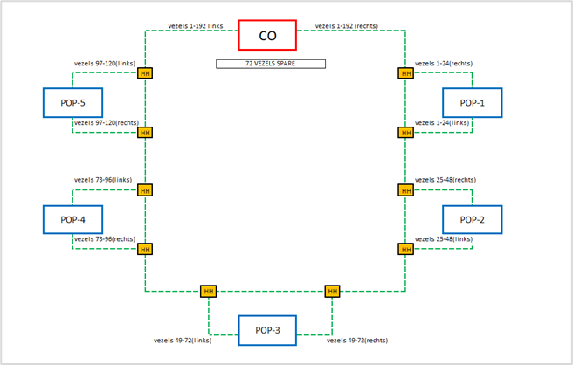
Figure 1: Fiberzones of several Area POPs, connected to Central POP by a POP Ring,
in principle forming a single Deployment Area

Unifiber Network Components
The Unifiber FTTx Network consists of three components:
- Access Network: the collection of all point-to-point connections between the Customer (or Access) Distribution Points/Handholes (being the ultimate Distribution Points towards the Business Customers), and all Business Access Points (installation addresses), including if connected, the fiber termination solution at each installation address, being one of the two following options:

  - Fiber Termination Unit (FTU) for Homes and SME
  - Optical Distribution Frame (ODF) for Corporate Business.
The default access to each Business Customer consists of a fiber pair.
- Distribution Network: the collection of all fiber cables between the Area POP and the different Distribution Points/Handholes at street level up to the last handhole, the Customer (or Access) Distribution Handhole. The distribution connectivity is standardly offered as a single fiber, but is 2-fiber capable, i.e. can be upgraded to 2 fibers (requiring additional splicing).
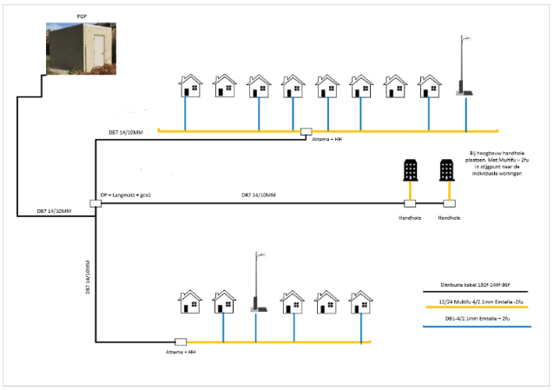

- POP Ring: the POP-ring connects the Area POPs with the Central POP per Deployment Area via a (manually) redundant ring network.
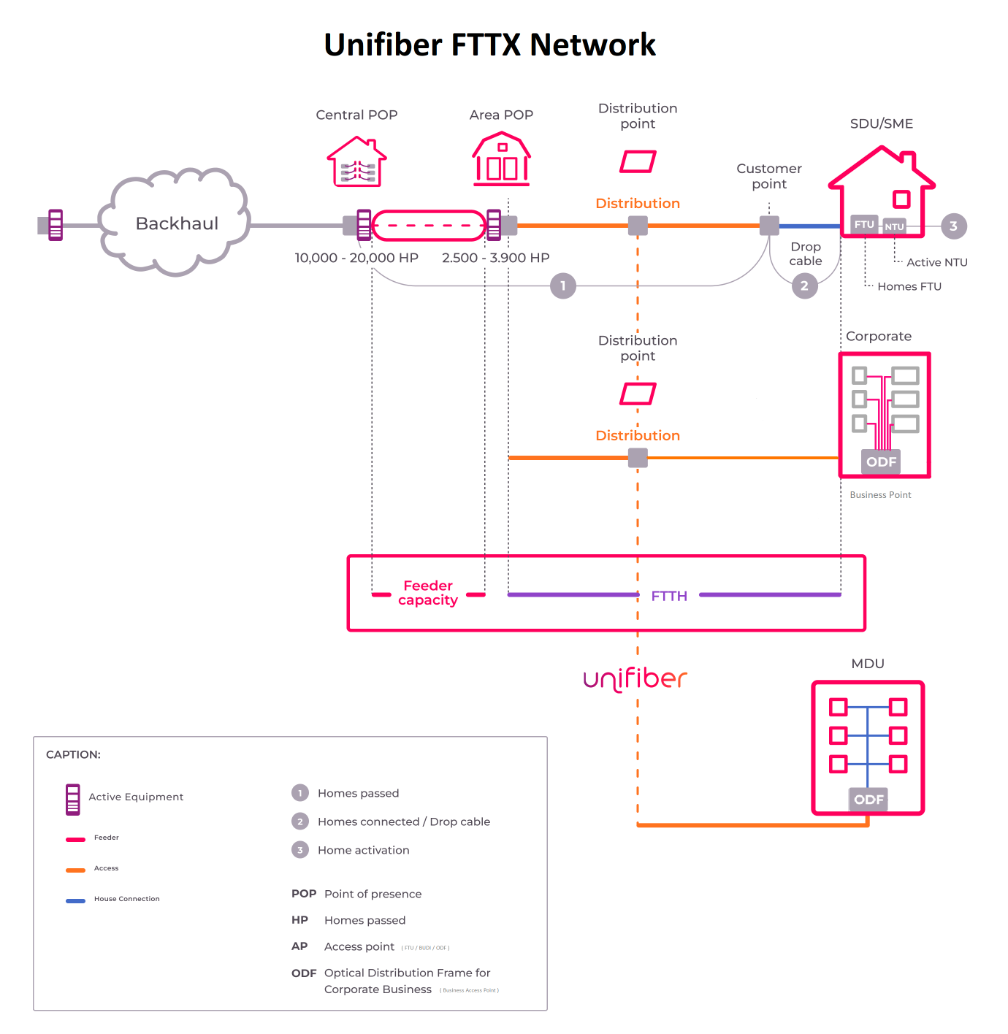

Backhauling
Backhauling allows the Operator to connect the Unifiber FTTx Network and its connected Business Customers to its own network.
Backhauling is the responsibility of the Operator. Operator can opt to build the backhaul himself or can make use of a Third Party Backhaul Service Provider to assure backhauling over the entire Unifiber FTTx-network.
The backhauling shall typically starts in a Central POP and can upon higher market penetration be extended to one or more or all Area POPs.
Operator is offered standard rack space (and on the event power) in the Area and Central POPs.
With this network topology hierarchy, Operator can opt in a first instance to install equipment and backhaul only at the Central POPs and use the POP-ring service by Unifiber to access Business Customers at the other Area POPs in the same Deployment Area. However, Operator can also choose to backhaul at one or more, even all, Area POP(s).
Operator has the option to backhaul directly to the Area POP on which the access line terminates or can centralize its backhaul at the Central POP and use a connectivity solution between the Area POP(s) and the Central POP.

Network Design Principles
Cf. Plan van Eisen

Network Quality Standards
The network is designed in such a way that following quality standards are guaranteed:
 | 1310nm | 1550nm | 1625nm
Attenuation per km | 0,35dB/km | 0,25dB/km | 0,28dB/km
Splice Attenuation DP | 0,10dB | 0,10dB | 0,10dB
Insertion Loss | 0,5dB | 0,5dB | 0,5dB
Optical Return Loss AP | ≤ -60dB | ≤ -60dB | ≤ -60dB

The total route attenuation at e.g. 1550nm has thus to be calculated as follows:
(L x 0.25dB/km) + (m x 0.5dB) + (n x 0.1dB)
With
- L being the length in km
- m the number of connectors
- n the number of splices
Unifiber provides a technical description how to connect equipment to the Unifiber network. The fibers of the outside plant cables are according to ITU G.657.A1. The number of intermediate connectors per link will be kept to a minimum. Splices will be preferred.

Demarcation & Operator Authorization

Business Access Point
The demarcation point of Unifiber’s network at the Business Customer side is the FTU or ODF at the Business Access Point.
The FTU exists of 2 ports, at least one of these ports will provide in the Customer fiber connection. Both fiber ports are known by a so called UTAC reference number, providing a unique ID for all future communication related to incidents, planned work or contractual changes. Each used fiber will be labelled at the Business Access Point with an UTAC.
All equipment behind the FTU (or ODF) falls within the responsibility of Operator.

POPs
In the Central and Area POPs, Operator has the authorisation to work only within his own Operator Rack (e.g. installation of own equipment such as OLT or Ethernet switches and patching of own cables within own rack). The networks specifications are to be respected in order to place equipment in the allocated racks at the Central POP.
All necessary connections to make between the Operator Rack and Unifiber equipment in the POP, e.g. to make the POP operational for Operator (such as connection to the powering) or (de)patching of Business Customers to the Unifiber ODF, will be done by Unifiber technicians or Third Party technicians working on Unifiber behalf. All Business Customer related patches will be labeled with a standard naming convention and reference number that relates to the Operator Order.

Ownership, Usage and Protection of Network and Equipment
The Unifiber FTTx network is built, operated and owned by Unifiber and Unifiber grants access to its network to Operators. Except for conditions mentioned in the SLA, Unifiber will not make any alterations to the network. Operator and Unifiber will treat each other’s equipment and facilities at the Central POPs, Area POPs and Business Access Points with utmost care.

Unifiber FTTX Network

Homes Passed Deployment
Unifiber is currently building a 600k FTTx Network in Wallonia. The FTTx Deployment is ongoing and planned to run from 2022 till 2028 at a cruising speed of 112.5k Homes Passed per Year.
The deployment is being delivered in areas of about 10k Homes Passed, usually within the boundaries of a single commune, called Deployment Areas.
An always updated status of the planned deployments for the next two years to come is consultable for all operators on a non-discriminatory basis via a portal on our website https://unifiber.be/portal (username and password required – please contact Unifiber’s Service Manager for access). This must allow each Operator to assess commercial potential and plan and prepare its commercial activities for the next 2 years.
Six months before start of deployment, first documentation on the streets and houses included in the Deployment Area are made available on the Portal in the form of Shape Files.
Operators can follow the advances in the build in a certain Deployment Area via the daily ‘Deployment’ update on the API.
Once 80% of the Homes in a Deployment Area are being delivered, called ‘Delivery’ (or ‘Initial Delivery’), the Deployment Area is made commercially available to all operators via a written ‘Ready for Service’-notification. Upon acceptance of the RFS notification by Operator (by acceptance of the RFS notification or upon expiry of a 20 Business Day period after RFS without response), an operator can start its commercial activities and sell services to the newly available Business Customers on fiber in that Deployment Area.
As from that moment, each Operator with whom Unifiber will have an agreement (both B2C as B2B) will receive all serviceable addresses via our API or Web interface.
In the meantime, Unifiber will continue its deployment in de the already released Deployment Area till minimum 95% of that area is covered. We strive Final Delivery to happen within 24 months after Initial Delivery.
The Unifiber FTTx Network roll-out is done in 2 waves (although the two waves may in practice be done consecutively in one wave):
- First the Homes Passed network is build (period of 6 months to 1 year from Start of deployment)
- Once the Homes Passed network is build and a Deployment Area has been RFSe’d, Homes will be Connected upon request from Operators to Activate a certain Home.
In some cases (depending on Deployment Area and specific Business Access Point situation), the HP Network deployment already includes some (partial) Homes Connect build. In the latter case, the Business Connection/Activation may be more simple upon Activation request from an Operator.

Business Connection
Before any service can be offered towards the Business Customer by Operator (= Business Activation), the Business Access Point needs to be connected to the HP Network (= Business Connected). In other words, there needs to be a fiber Drop Cable, connecting the Business Access Point via an FTU or ODF to the FTTx Network.
There are two ways that the Business Access Point is already connected to the FTTx Network:
- The Business Access Point has been connected during a combined HP and HC Deployment (see paragraph above);
- The Business Access Point has been connected upon request for Activation from another Operator previously (and likely Operator Swap now).
The status of each serviceable address is consultable in the Address Register. One of the three following options are possible:
- Business Passed
- Business Connected
- Business Activated
In case a serviceable Business Access Point is not connected yet (status Business Passed), Unifiber (through its contractor) will first create a fiber connection from the nearest point in our network towards the Business Access Point. Depending on the deployment type that was used to deploy our network (underground, façade or aerial), this installation process either requires trenching activities, façade and internal cabling works, solely internal cabling works (in case of an MDU, a Multi Dwelling Unit) or realizing a drop cable via existing aerial ‘drops’ and continue either via trenching or façade to the Business Access Point.
As we realize that Business Customers can be heavily dependent on stable and reliable networks and need to support their customer base when required, Unifiber offers the possibility for the Operator to provide multiple suitable installation timeslots upon preference. The Unifiber contractor will contact the end-Business Customer to discuss the order, re-confirm the planned date and acquire additional information to support and prepare for each customer-specific deployment situation.

Service Description
An overview of the complete Unifiber Product Offering, including both B2C as B2B product offerings, is shown in Figure 1.
The B2B Service Offering consists of the following products:
- 2 distinct Wholesale Business Access Products:

- Wholesale Single Fiber (1F) Business Access for a single fiber between the Business Access point and the Area POP
- Wholesale Fiber Pair (FP) Business Access for a fiber pair between the Business Access Point and the Area POP or the Central POP.

- Rackspace (or Co-location) to allow aggregation and backhauling
Unifiber shall offer lead times in alignment with Operator and a customer-oriented connection process with a Premium SLA (see Annex 4 for Specifications).
The connection appointment for Business Access is dedicated to the Business Customer that is to be connected. “Dedicated” means a dedicated time slot for an appointment during regular working hours (any time from 7:00 to 18:00 and upon request on Saturday AM).
The Service Offerings for both Business Access Services is described in more detail in the following paragraphs.

Wholesale Single Fiber (1F) Access
Unifiber’s Wholesale Single Fiber (1F) Access product consists in providing a single dark fiber connection from an connectable Business Access Point to the Area POP where Operator then connects to its ODF.
Per Access Line, the following components are provided:
- the physical passive P2P single fiber connection from the FTU at the Business Access Point to Unifiber’s ODF in the Area POP;
- a patch which provides connectivity from Unifiber’s ODF to the Operator rack in the Area POP.
The Operator may request up to four (4) 1F access lines for each single Business Access Point.
The connectivity of Operator’s Single Fiber Access Lines in an Area POP to the Central POP is done via Ethernet, based on a direct two fiber connection between each Area POP and the Central POP. The Ethernet equipment is owned, installed and operated by Operator.
Operator may order fibers from each Area POP to the Central POP per fiber pair .

Wholesale Fiber Pair Business Access
Unifiber’s Wholesale Fiber Pair Access product consists in providing a dedicated dark fiber pair connection from an connectable Business Access Point to Operator’s backhaul in the Central POP via a P2P connection end-to-end.
The Operator may request up to two (2) FP access lines for each single Business Access Point.
Per Access Line, the following components are provided:
- the physical passive P2P fiber pair connection from the ODF at the Business Access Point to Unifiber’s ODF in the Area POP;
- a patch which provides connectivity from the access fiber pair’s positions on Unifiber’s ODF in the Area POP to a free dedicated fiber pair on the POP Ring from the Area POP to the Central POP;
- a patch which provides connectivity from the fiber pair POP Ring termination on Unifiber’s ODF at the Central POP to the Operator rack in the Central POP.

Rackspace
Unifiber provides rackspace in POP location to allow Operator to do aggregation and backhauling in the Central POPs of Unifiber. This product also allows Operator to offer Wholesale Backhauling services to other Operators on our FTTx-network as a Wholesale Backhauling Service Provider.
See appendix 1 for more information on the POP Location Services.

